 | Tsegi Wash
 | 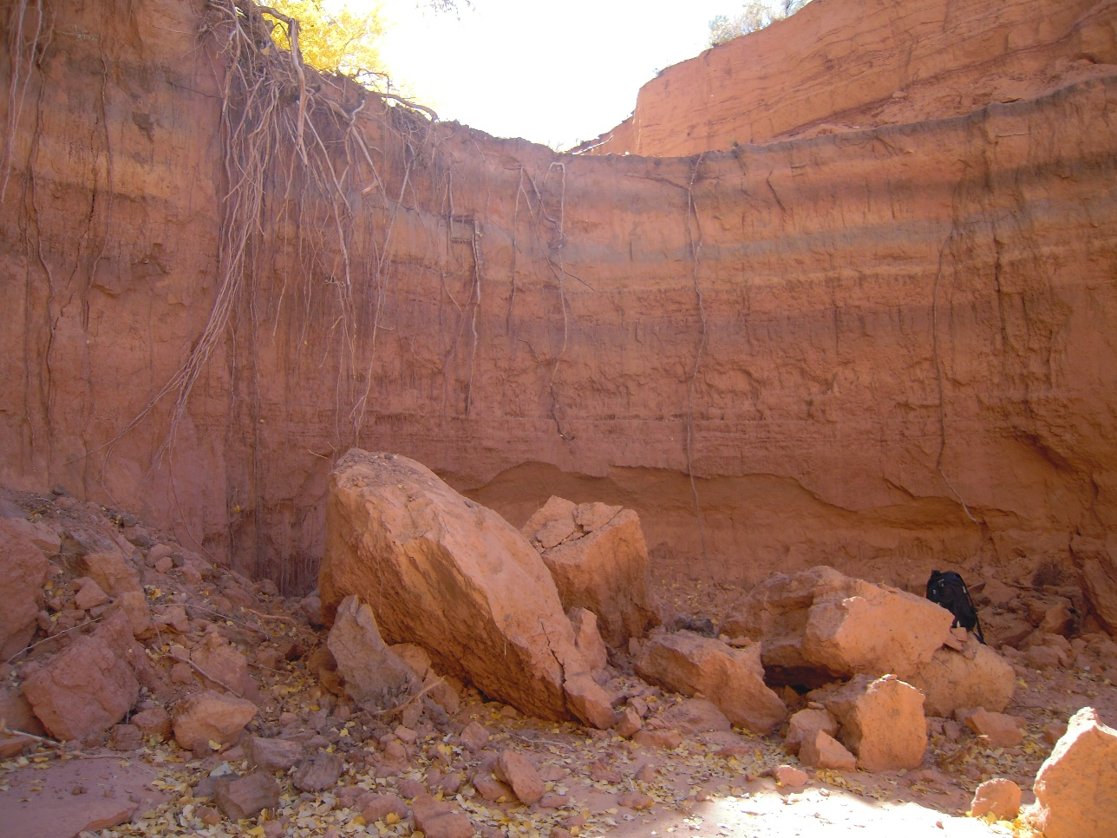
12/6/2013 | Dan Larson, Leticia Delgado, Jessica Carnes

Tsegi Wash Group
Northern Arizona University
S San Francisco St.
Flagstaff, AZ 86011

December 6, 2013

Mark Lamer
Northern Arizona University
S San Francisco St.
Flagstaff, AZ 86011

Dear Mark Lamer,

Over the past 3 years, our team has been preparing to implement the skills we have learned in the classroom and apply them to a project such as the one presented. As environmental engineering students, we are especially interested in working on a project dealing so closely with our studies and being able to demonstrate our capabilities. Our team is excited to work with you on this project and welcomes any comments and advice you may be able to provide.

The following proposal and attached appendices present the intentions for this project as of December 6, 2013. The proposal discusses project understanding and description, scope and schedule, and project cost.

Thank you for your time. Please contact us with any comments or concerns.

Sincerely,
Tsegi Wash Group

Leticia Delgado
Ld266@nau.edu

Jessica Carnes
Jrc293@nau.edu

Daniel Larson
Dcl65@nau.edu

Table of Contents

1.0 Project Understanding …………………………………………………….………...1
1.1 Purpose ……………………………………………………………………...1
1.2 Background …………………………………………………………………1
1.3 Project Description ………………………………………………………….1
1.4 Stakeholders ………………………………………………………………...2
2.0 Project Scope ………………………………………………………………………..2
2.1 Site Assessment ……………………………………………………………..2
2.2 Hydrology …………………………………………………………………...2
2.3 Hydraulics ……………………………………………………………….......3
2.4 Armoring Design ……………………………………………………………3
2.5 Impacts Evaluation ………………………………………………………….3
2.6 Exclusions ………………………………………………………………......3
3.0 Project Schedule …………………………………………………………………….4
4.0 Project Cost …………………………………………………………………………4
List of Tables

Table 1. Cost of Services ……………………………………………………….….......5
Table 2. Pay Rates ……………………………………………………………….…….5
Table 3. Overall Cost …………………………………………………………….…….6

List of Figures

Figure 1. Aerial View of Nitsin Canyon and Surrounding Area …………….…..……..2
Figure 2. Site Location .…………………………………………………….…….…….2

Appendices

Appendix A. Gantt Chart……………………………………………...………………..7

- Project Understanding

1.1 Purpose

The purpose of this project is to design a stabilization method to minimize soil erosion and stream scour of a channel headcut.

1.2 Background

Tsegi Wash is located in Nitsin Canyon, west of the Navajo National Monument. Navajo National Monument is divided into three units, the designated unit for this project will be the Inscription House unit, which is comprised of 40 acres. Inscription House has been closed to the public since 1968 to preserve the site. Around 50 years ago the canyon consisted of farmland and housing structures, but around 40 years ago the headcut began spreading along the canyon reducing the available farmland. The only current land user inside the canyon is Jerry H. Begay whose cattle is causing the soil erosion problem due to their grazing. As the cattle graze they uproot the grass, which is one of the only sources of stabilization for the canyon. The canyon drains 30 miles downstream into Lake Powell. The annual rainfall in nearby Kayenta is 12.81 inches with August being the wettest month.

1.3 Project Description

The existing site consists of a 23-foot headcut, which is an abrupt vertical drop in the channel. The lack of soil stability near the site is due to the cattle grazing and lowering of the water table. The vegetation at the site includes cottonwood trees, willows, and shrubbery. The bed material at the headcut is a sandy soil. Currently, the only source of stabilization at the headcut comes from the roots of the nearby cottonwood tree. The headcut is located a quarter mile upstream from the point water source at the canyon. Below is an aerial view of the canyon where the site is located.
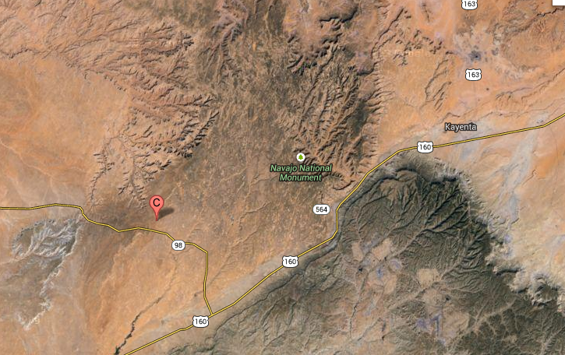Figure 1. Aerial View of Nitsin Canyon and Surrounding Area

Below in Figure 2 is a zoomed in view of the headcut location.

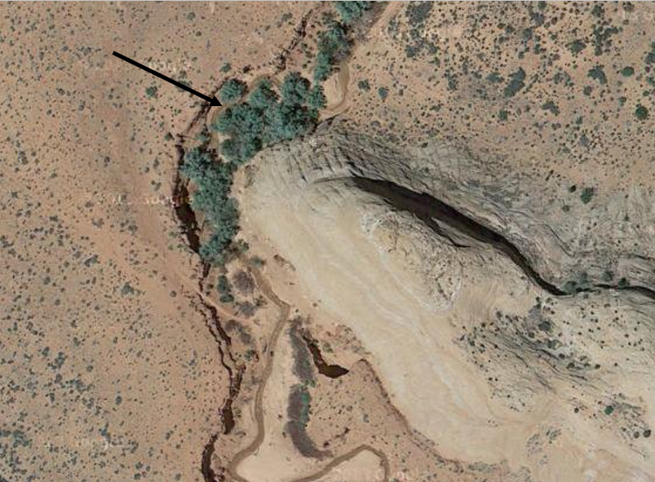
Figure 2. Site Location

As seen above, the headcut occurs among the cluster of cottonwood trees, as shown by the arrow.

1.4 Stakeholders

Key stakeholders involved in the project include the following:
- Bureau of Indian Affairs
- Navajo Nation
- National Park Service
- Local Residents
- Visitors/Tourists

The Bureau of Indian Affairs is the federal agency for the region where the site is located. The agency is providing funding for the project. Navajo Nation is the governing body that holds jurisdiction for the area. The National Park Service works in conjunction with Navajo Nation to preserve areas of significance, such as Navajo National Monument. The living conditions and loss of property of local residents can be at risk due to the unstable soil conditions. Visitors and tourists can be exposed to dangerous site conditions.

- Project Scope

The following section details the tasks of the project, listed in the order they will be performed.

2.1 Site Assessment

The site assessment will include the following:
- Site Visit - evaluate the current conditions of the headcut and document with pictures
- Land Use Survey – determine the residential and commercial uses of the properties surrounding the site, i.e. cattle grazing
- Roughness Coefficient – determine the Manning’s coefficient based on the bed material of the channel

2.2 Hydrology

Hydrology is the study of the movement, distribution, quality of water, and physical flow conditions. The task will consist of the following:

  - Delineate Watershed – create a boundary that shows water flow to the site
  - Hydraulic Radius – cross-sectional area divided by wetted perimeter
  - Gage Data/Research -historic data of daily flows collected by United States Geological Survey (USGS) in the area
  - Determine Flow – use historical data and cross sections combined with open-channel flow equations such as Manning’s and continuity to solve for flow
  - Determine Velocity – use open-channel flow equations such as Manning’s and continuity to solve for velocity

2.3 Hydraulics

Hydraulics is the study of the mechanical properties of liquids to determine flow characteristics. The task will include the following:

- Modeling Software- HEC-RAS (Hydraulic Engineering Centers Rivers Analysis System) will be used to create representative various flow conditions at the site for a 10-, and 25-year flow. 100-year flow will also be considered but not modeled extensively.
    - Flow Characteristics
      - 10-, 25- year flow – maximum flood scenarios to be ran using the software
      - Bankfull discharge – rate when water is flowing at full channel height
      - Frequency- number of years between flood event cycles
      - Duration- how long flood conditions will exist during flood events

2.4 Armoring Design

This task will consist of determining the best possible stabilization method for the headcut. Three armoring methods to be considered are:
- Live Planting: Use of native vegetation
- Bioengineering: Use of structural materials combined with native vegetation
- Hard-Armor: Use of various sized rocks i.e. riprap and gabions
Constraints when designing the stabilization include the difficulty involved to reach the site, the large size of the headcut, lack of funding, and minimal natural vegetation at the site to incorporate.

2.5 Impacts Evaluation

An impacts evaluation will be performed on the final design to asses economic, cultural, and ecological impacts of the armoring.

2.6 Exclusions

Exclusions on the project include the following:

- Soil Analysis
- Extensive Surveying
- Geotechnical Analysis
- Vegetation Analysis

- Project Schedule

A schedule of the project can be seen in Appendix A. Deliverables for the project consist of the following:
- Website – December 6, 2013
- Final Proposal – December 6, 2013
- Final Presentation – December 17, 2013
- 50% Design Report – March 13, 2014
- 50% Design Report Presentation – March 13, 2013
- Final Presentation – April 25, 2013
- Final Design Report – May 1, 2013

- Project Cost

Table 1 below displays the cost of engineering services to complete the project.

Table 1. Cost of Services
Task | Senior Engineer  (hrs) | Engineer  (hrs) | EIT  (hrs) | Tech  (hrs) | Admin. Asst.  (hrs) | Total Hours | Total Cost of Task
Fieldwork |  |  | 14 | 10 |  | 24 | 1399.2
Hydrology |  | 30 | 40 | 30 |  | 100 | 7735.2
Hydraulics |  | 20 | 20 |  |  | 40 | 4048
Armoring Design | 35 | 25 | 10 | 10 |  | 80 | 9417.65
Impacts Evaluation | 20 | 4 |  |  |  | 24 | 3495.8
Document | 20 |  | 30 | 20 | 70 | 140 | 9617.3
Total | 75 | 79 | 114 | 70 | 70 | 408 | 35,713

Table 2 below shows the pay of each member working on the project.

Table 2. Pay Rates
Person | Base Pay, $/hr | Benefits, % base pay | Actual Pay $/hr | Profit, % actual pay | Billable Rate, $/hr
Senior Eng. | 105 | 30 | 136.5 | 10 | 150.15
Engineer | 70 | 60 | 112 | 10 | 123.2
EIT | 45 | 60 | 72 | 10 | 79.2
Tech | 22 | 20 | 26.4 | 10 | 29.04
Admin. Asst. | 25 | 90 | 47.5 | 10 | 52.25

Table 3 displays the overall cost of the project including personnel, travel costs, subcontracting, and overhead.

Table 3. Overall Cost
1.0 Personnel | Person | Hours | Rate, $/hr | Cost, $
 | Senior Eng. | 75 | 150.15 | 11,261
 | Engineer | 79 | 123.2 | 9,733
 | EIT | 114 | 79.2 | 9,029
 | Tech | 70 | 29.04 | 2,033
 | Admin. Asst. | 70 | 52.25 | 3,658
 | Total Personnel |  |  | 35,713
2.0 Travel
 | 2 visits * 254mi/visit | $0.40/mi |  | 203
3.0 Subcontractor
 | Surveying |  |  | 7,500
 | Geotech Analysis |  |  | 5,000
 | Vegetation Analysis |  |  | 2,500
 | Total |  |  | 15,000
4.0 Overhead |  |  | $/mo
 | Rent |  | $1,500
 | Utilities |  | $500
 | Supplies |  | $750
 | Vehicle |  | $1,000
 | Admin |  | $1,500
 | Total Overhead |  |  | 5,250
 |  |  | w/ 50% profit | 7,875
Overhead Hourly Cost | 15.12 | $/ hr
Apportion Overhead | 0.72
 |  |  |  | 4,416
5.0 Total |  |  |  | 55,332

The final cost of the project is estimated to be $55,332.

Appendix A

